pipeline job for docker image build and push

Create a Dockerfile for building the image in the location where Jenkinsfile is created.

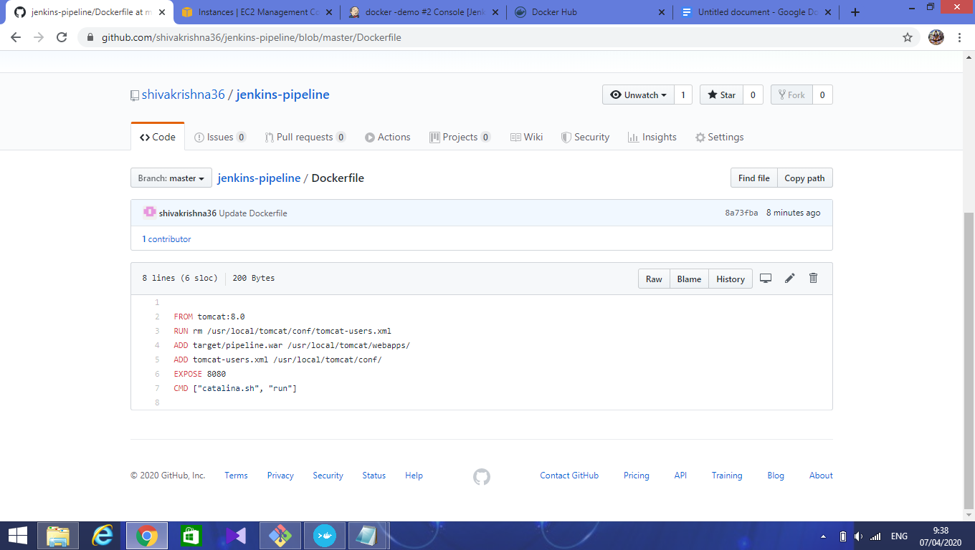

Jenkinsfile script for Docker image build and push into docker hub.

One stage for building image and other stage for pushing to docker hub.

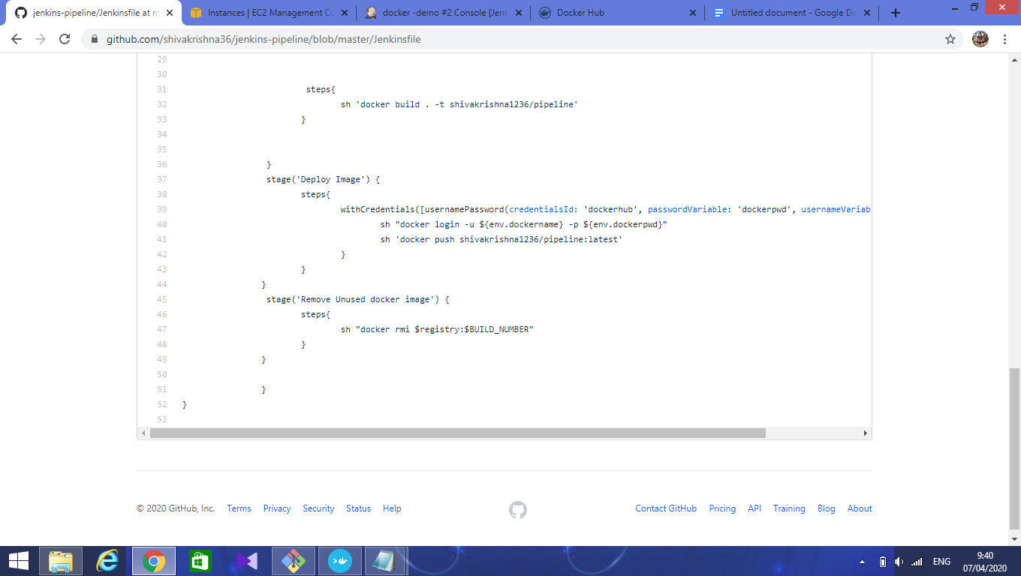

In jenkins dashboard, configure the docker hub credentials and use in Jenkins file.

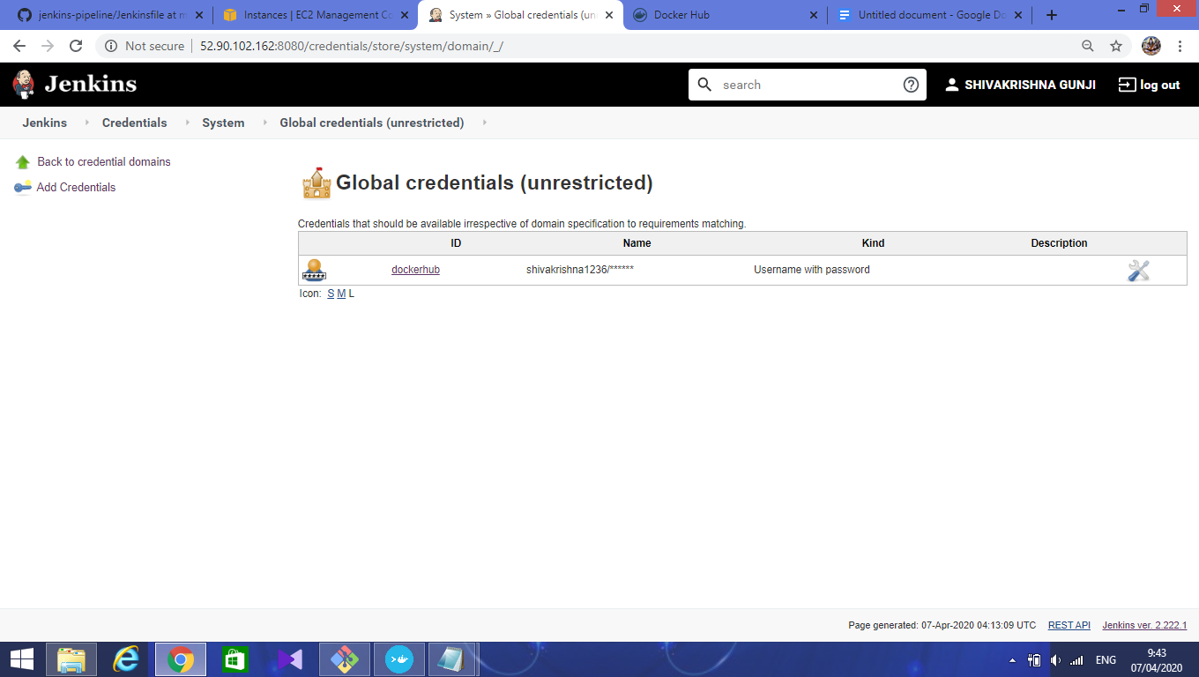

Create a jenkins pipeline job as shown below

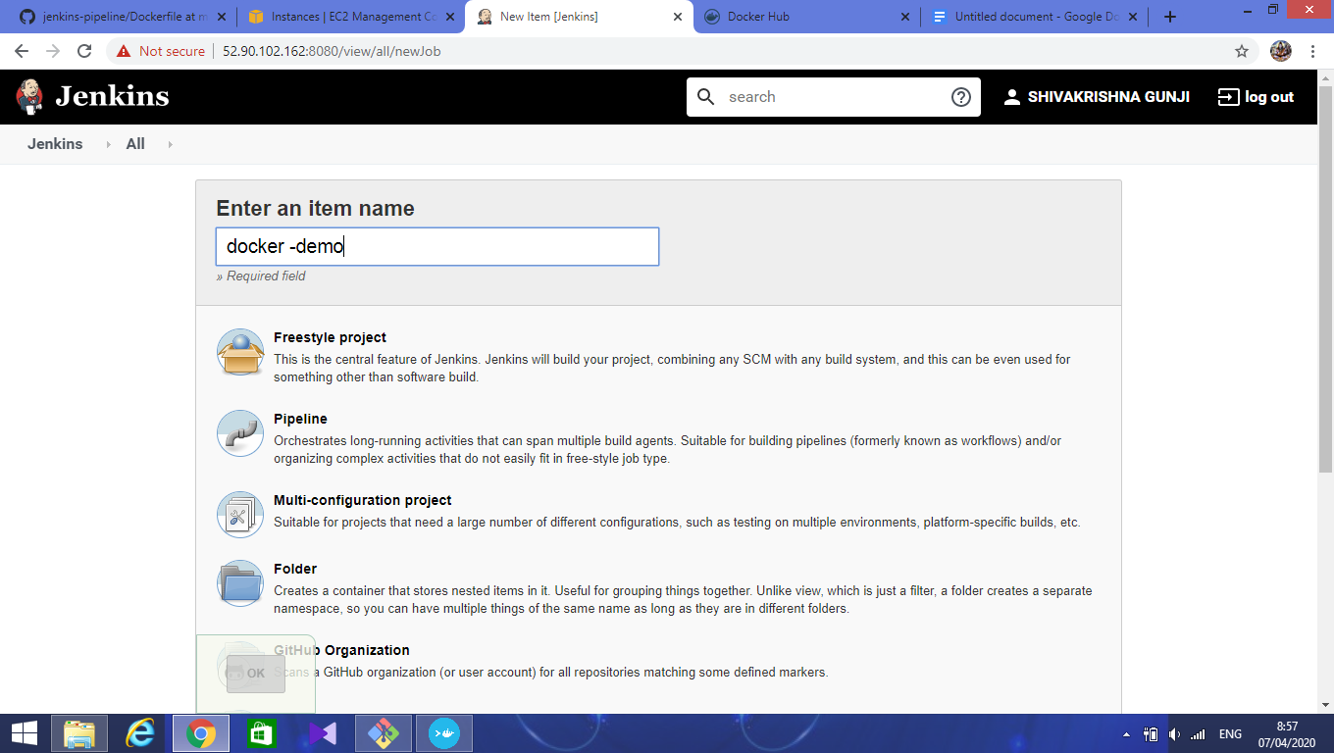

In the pipeline section, select **pipeline script from scm**.

In SCM, select **GIT**.

In repositories, enter github link in repository url.

Enter the branch if no master of your repository.

In a secret path, path of Jenkinsfile .

Click on **Save** and **Apply**.

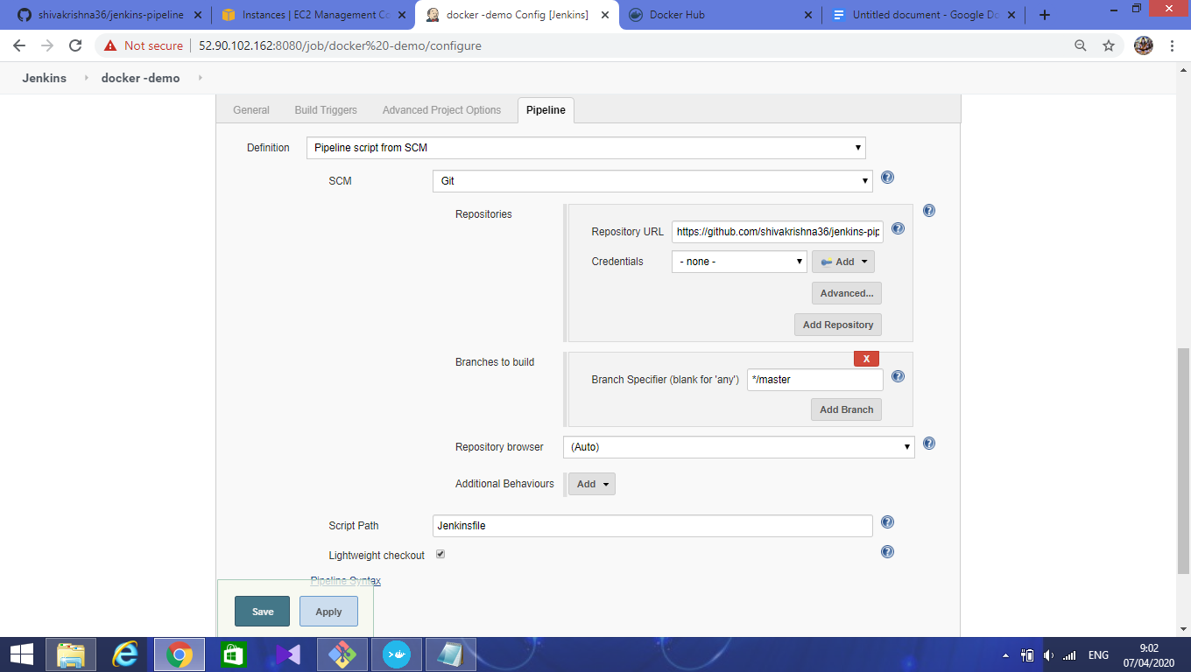

Click on build now in the dashboard.

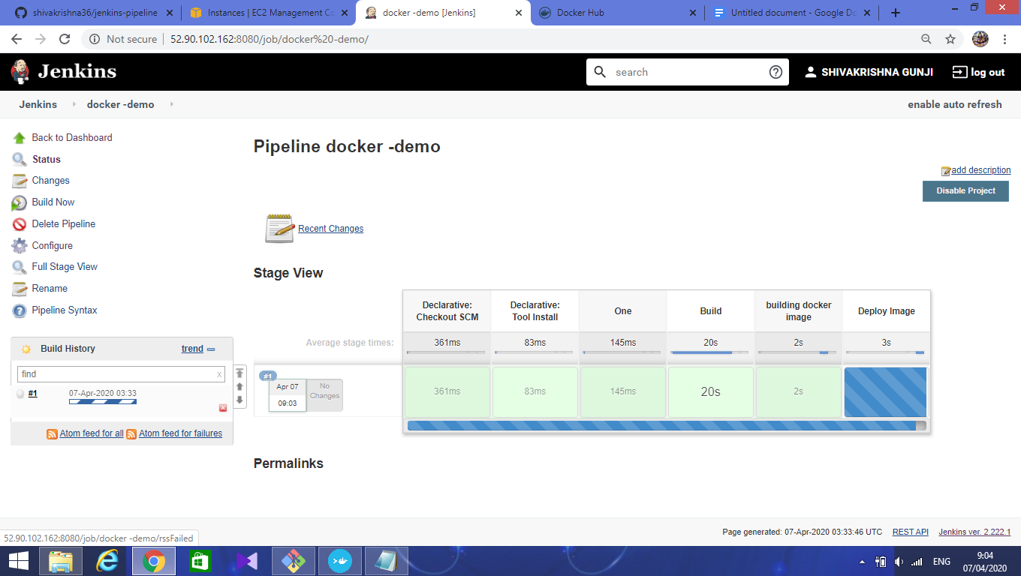

It will build stage by stage as shown in image.

In console output, we can see that dockerfile executing in step wise.

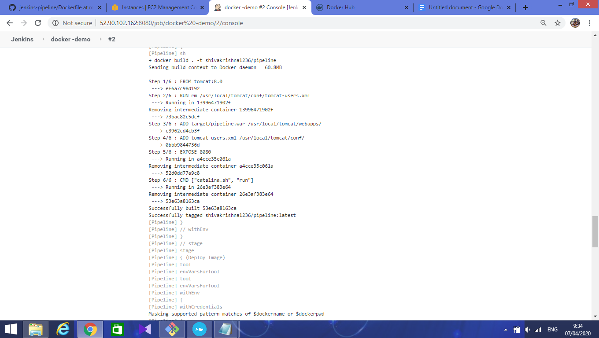

Successfully built the docker image.

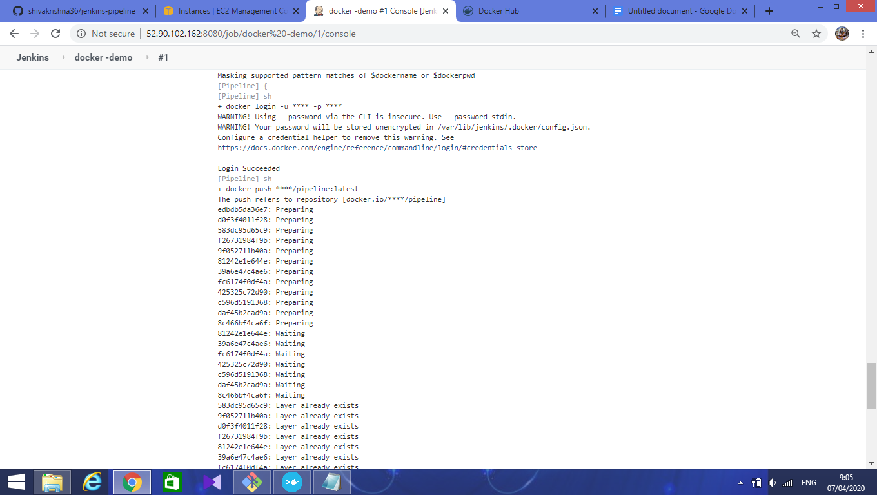

After next it will push the image into the docker hub registry.